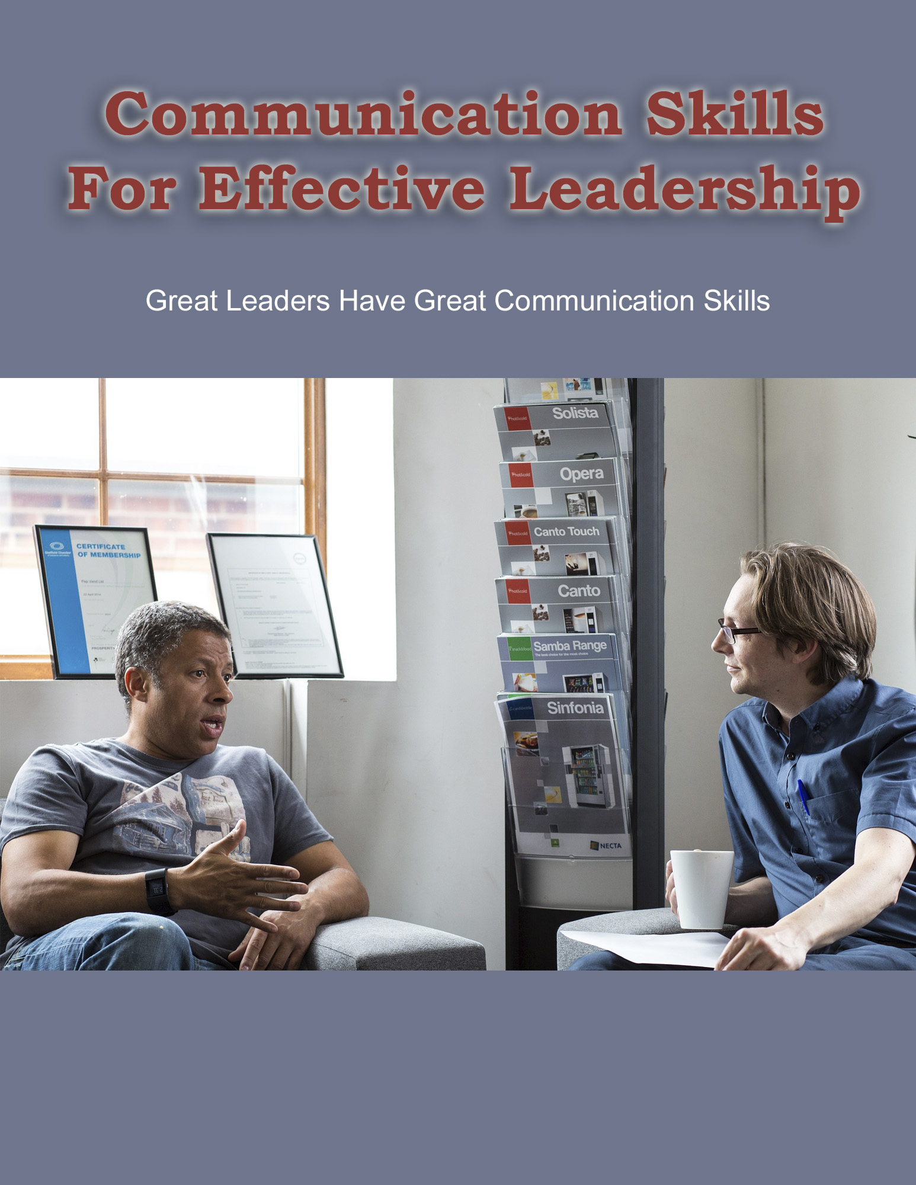
Good communication skills are crucial in a leader if they are to remain a leader. A leader can be defined as someone who plays a prominent role in a business or a department within it. There are also religious, political and community leaders, leaders of groups and teams, and so on. In this guide, we will be looking at business leaders and how good communication skills are an important part of effective leadership.
Let’s start with a definition of a good leader, and how they show they are a good leader through their communication style and choices.

WHAT IS EFFECTIVE COMMUNICATION IN A GOOD LEADER?

Some people seem to be born leaders, while others have leadership thrust upon them. History shows us that many people who come from fairly humble origins have been suddenly transformed into legends in their own time and beyond. What creates a Julius Caesar or a Napoleon? What creates in our own era, and with less conquering involved, the likes of Richard Branson, Steve Jobs and Warren Buffett?
The one thing they all have in common is that they are effective communicators, and one might even say "spin doctors". They understand the importance of conveying a vision people want to participate in. Julius Caesar and Napoleon both understood propaganda and were able to convince people that their defeats were actually victories. Effective modern leaders like Branson and Jobs built companies from scratch, with every worker becoming convinced of the importance of the mission and willing to do their part.
In every opportunity for leadership, there will be obstacles, pitfalls and tough times - not just successes. It is how someone responds to these tough times, and to their many critics who want to pick them to pieces, that can be the sign of a great leader.
As with many things in life, timing is also critical. Learning how to communicate effectively to your chosen audience at the right time and the right place can be difficult, but can reap great benefits.
Know Your Audience
The most important aspect of any effective communication is knowing your audience. This audience will vary, so being flexible in your communication styles is a great skill for any leader to have. In the course of a single day as the leader of a business or department, you might speak to:
- Staff
- Shareholders
- Business partners
- Prospective business partners
- Vendors
- Customers
- Children taking a tour of your facility
...and more.

How you speak to them, and what you choose to say or not say to them, is key to successful communication. For example, you wouldn’t go over your Q4 sales results with the children. And you wouldn’t give departmental reviews to your customers - only to your staff.
The Right Timing
Timing is also key. For example, no business leader looks forward to giving out bad news, but sometimes the more you avoid it, the worse things can become. If there is a downturn and you have to start laying off people, this needs to be conveyed sooner rather than later.
The Right Style
Using the example of having to give bad news, you also have to choose your moment and communication style. Should you say nothing to anyone other than those getting the pink slip? Email everyone? Or should you send out an email to make a date for a very important meeting?

Once everyone is at the meeting, how should you announce the news? Do you just blurt out that there will be layoffs and leave it at that? Or will you explain the reasons behind the decision, what the next steps will be, and what you think will happen going forward?
Listening is just as important a leadership skill as speaking. Will you give staff a chance to ask about the redundancies and the situation as a whole? Or leave it to your managers?
Once the meeting is over, you will then have a number of follow-up steps and options. Will you speak to each person getting the pink slip, or let your hiring manager do it? Or will these workers just be given notice and no-one will say a word of regret or appreciation for all their past efforts?
Sometimes communication, for good or ill, comes from not saying anything at all. A worker with a pink slip who has not been given clear reasons or thanked is likely to feel a lot more disgruntled than one who is treated like a human being.
What You Say and Don’t Say Does Count
On the other hand, going into too much detail might open up an entire legal minefield if the worker believes the lay-off is because you "don’t like them" or some form of discrimination is going on. Accusations of racism, sexism, age-ism and other forms of discrimination can all damage your company and even leave it open to serious financial repercussions.
Therefore, it is very important to be clear about the way all workers are spoken to, and this will come from you as the leader, to filter down to managers and staff. Any forms of off-color jokes, bullying or aggressive tendencies should be discouraged at all times, and in all forms - including email and social media accounts, as well as face-to-face dealings between colleagues. Even "harmless teasing" can be hurtful and seem bullying to some individuals.
Following Up
Whenever something important is being conveyed, follow-up can make all the difference between success and failure.
Using the lay-off example above, for those staff who remain after the cuts, holding another meeting to talk about the next steps will be important. Meetings will also need to be held in order to make sure every task that the people who were laid off were doing will be covered now that they are gone.
Being Visible
When times get tough, even the best leaders want to just go in their office and hide. But being visible can often be one of the best forms of leadership. So too can an open-door policy, in which people feel that they can come to you with questions and concerns and that these will be taken seriously and treated with respect.
Setting the Tone
The most important aspect of leadership can often be to set the tone. A positive, upbeat leader with a can-do attitude is more likely to gain followers than someone who delivers consistently negative messages. Even when things are bad, a leader with good communication skills will be able to reframe the issues in such a way as to maintain a loyal following.
For example, in terms of the lay-offs, it should be made clear that these short-term losses are being made in favor of long-term gains.
If two departments are merged, a good leader would indicate all of the benefits and how the work can be done more efficiently.
Conveying Change
Many people hate change. Even though it is an inescapable fact of life, people get so comfortable in their routines that any change can be very upsetting and even seem like a serious threat to all life as they know it. In most cases, this will not be true, but having empathy for this point of view can help smooth out the transitions.
Holding Regular Meetings
Regular meetings are a chance to communicate clearly and get feedback. Don't just have meetings for the sake of having them. Have clear reasons to meet, agendas, and action steps at the end of each meeting. Follow up in a timely manner on any of the action steps that result from these meetings.

Being a Good Listener

Many people believe that being a good leader is all about speaking powerfully. The truth is that a good leader listens as well. They show empathy, value opinions and are constantly learning from others rather than thinking they have all the answers.
Understand that people are only human. Everyone makes mistakes. If a mistake was made, find out the reasons why it happened. Listen and share viewpoints. Seek ideas and innovations. Give people another chance if you think they deserve it.
Treat colleagues the way your best boss treated you. We can never walk in another person's shoes, but we can try to be more understanding and tolerant if they are having professional or personal problems, so that everyone feels valued.
Never Assume
Always be clear in your verbal and written communications. Confirm anything important in writing, including email, such as after a phone conversation or team meeting. Check and double-check, especially when any deadlines are approaching. It is better to summarize important points and dates briefly in your communications and repeat yourself, for example, than assume that everyone knows it all already when they might not.
These are some of the most important aspects of effective communication if you are a business leader. Your approach will differ somewhat depending on whether the communication is verbal or written. Let’s look in the next section at verbal communication.

EFFECTIVE VERBAL COMMUNICATION

Verbal communication is often taken for granted because we can all speak, even if we are not good writers. However, effective verbal communication does not come naturally to everyone. Fortunately, it is a skill that can be learned with a bit of time and effort.
The Importance of Verbal Communication
Spoken words matter beyond just the clear exchange of information. Style and tone of delivery can also affect what is being said and how it is being received by the audience.
Speaking in person and over the phone clearly and concisely is an important skill for any leader to develop. In addition, a good leader must understand the difference between the two and other things that contribute to communication other than the words and phrases being used.
Face-to-Face Communication
Communicating in person can be one of the most efficient ways to convey ideas and open up the floor for discussion. It may not, however, be the most efficient way to give detailed information. Knowing the difference between the two can often mean the difference between success and failure when it comes to planning new projects and initiatives.
For example, it's great to be able to chat face-to-face, but a rushed conversation as you are passing someone's desk is not an efficient way to expect things to get done correctly. A formal meeting or an email would be a better choice.
Body Language
Your body language will say a lot about who you are as a person and what your communication style is. Careless body language can also undermine the message that you were trying to convey. If your body language does not match your spoken words, there can be a serious disconnect which can be confusing or suggest to people that you are not telling the truth or are in some sort of mood.
For example, if you speak and listen with your arms crossed in front of your chest, this could relay a number of negative messages. Your audience might think you are defensive, angry or disinterested, especially if you don’t look at them or turn sideways.
Folded arms also send out the signal that people are supposed to stay away from you. They might even indicate stubbornness or refusal, so that people may never ask for what they need because your body language already seems to be telling them no.
Act Natural
A more relaxed and natural body stance with your arms hanging loosely at your sides is a much more welcoming posture when you are dealing with people face to face.
When speaking, try not to fiddle. Practice stillness. Maintain eye contact. If you are in a large group, look around the room. Don’t pace, but do move around as needed. When listening, nod your head. Listen carefully. Don’t try to jump in to speak. Wait until the person has finished. Then repeat what you understand to be the essence of the question, in case anyone hasn’t heard, and to be sure you have heard correctly.
Tone of Voice

Tone of voice has a large part to play in spoken communication - both in person and particularly on the phone. For example, the sentence, "Thanks for joining us" could be sincere and pleasant-sounding if it is uttered at beginning of the meeting. However, if it is said to a person coming in 20 minutes late, with an emphasis on the word "Thanks" it can come off as sounding very sarcastic and perhaps even rude.
Similarly, "Thanks a lot" carries different meanings when spoken versus when you read it on a page. It can be an expression of gratitude, or it can be sarcastic. Tone of voice is key.
Hosting Meetings and Presentations

If you are a business leader, sooner or later you are going to have to be in charge of meetings and give presentations. How well you do this could make or break your reputation as a good leader. If you are an organized leader who has a clear agenda and can get through a meeting in an efficient manner which will evoke positive outcomes, then your leadership will not be called into question.
If on the other hand things start to disintegrate into aimless back-and-forth arguments and no work gets done, these meetings will have no positive outcomes and will tarnish your reputation as a solid leader.
In terms of presentation such as PowerPoint decks, these days many businesses live and die by their decks. Therefore, it is really important to focus on this skill so you can create and give presentations that will maintain interest, persuade, and inform, rather than send people off to sleep.
Public Speaking

In the course of meetings, presentations, conferences and so on, you will have to speak in public to audiences both large and small. Studies have shown that public speaking is the number one fear that most people have, while death is only number three. As someone once joked, this means most people would rather be in the coffin than give the eulogy over it.
However, this does not have to be the case. There are many ways to practice public speaking in order to become better at it and do it with more confidence and effectiveness. It is just a case of being willing to put in the time and effort to practice until you are perfect.
Or, if you are not perfect, at least you can do a much better job than you are doing at the moment - if you feel that this is a personal weakness that needs to be addressed in order to become a better communicator and leader.
Conveying Confidence
One of the reasons why it is so important to be a confident presenter is that if you look and sound confident, your audience will feel confident in your message, and that you are telling them the truth and not covering up anything.
Going back to the example of having to indicate that lay-offs are imminent, people will feel much more confident about the future of the company if you sound positive about this being a necessary development for the strength of the company going forward. If you sound hesitant, nervous, or unsure about the need to take these steps, your audience in turn will also grow nervous.
Inspiring Your Audience

Great leaders inspire people to follow them. Julius Caesar would have never been able to cross the Rubicon and become the leader of the Roman Empire if he had lacked confidence or shrugged his shoulders as if to say, "Well, maybe it will work out." Instead he said, "I came, I saw, I conquered."
In every company, there will be certain leaders who set the tone and who people look to for inspiration. Even if you are currently working in a job that has no leadership responsibilities at the moment, it is still possible for you to set the tone and take the lead on projects and initiatives.
If you are willing to do so and can inspire people to follow you, it will be easy to demonstrate your leadership potential, and use what you accomplish as concrete examples of real achievements when it comes time for your end-of-year review or you decide you want to ask for a raise.
For all these reasons, face-to-face communication is key to getting things done and sharing a common vision for what the company is supposed to be like. Phone calls can help as well.
Effective Communication over the Phone
Conversations on the phone can be a fast way of getting things done, but they can also leave room for confusion if you're not clear about what you want to discuss at the start, and what the outcomes are of that phone conversation.
It is great to chat, but sometimes you might go around in circles. You might also end up seeming to agree to a particular action step, only to find that the person you were speaking to forgot that part of the conversation. This means you might expect something important to get done, but it never materializes.

The best way to handle phone conversations are to plan them ahead of time as much as possible. If you have to make any "cold calls" - that is, call people you don’t know in an effort to try to do business with them, determine their level of interest and ask for a follow-up call at a set time that works for them, and/or an email address where you can contact them.
Don’t try to push ahead like a charging bull. You might just get a no as a result and end up with no opportunity to have a meaningful conversation. People are busy, especially journalists. If you are trying to pitch a story to them, for example, and you ring them when they are on deadline and try to launch straight into your pitch, you will most likely get a "no, and don’t call again."
On the other hand, if you call and ask if it is a good time to talk, and whether they are on a deadline, they will see that you understand their working conditions and time constraints. If you then explain that you would like to pitch a story, ask when would be a good time to call back, and whether they would prefer the phone or email.
If you schedule a follow-up call, be organized. Jot down talking points prior to each call. Check them off one by one. Make notes as needed.
If you are worried you might miss something, use dictation software such as dictation.io. While it is true that you will only be able to record your side of the conversation, in this way you will at least have your side of things. You can take notes about what they say as needed.
Once the conversation is over, review your notes and type them up so they make sense. Once you are sure you have an accurate summary of what was discussed, send an email thanking the person for their time. Send a copy of the notes that you have made.
In particular, highlight any action steps, deadlines, or follow-ups that need to be taken. In this way, you can ensure that you are on the same page about what was said. You can also ask if there was anything you missed, or anything else they wanted to discuss. Ask them to add it to the email, or arrange another call.
Once they have offered their input, you will end up with a shared document and "paper trail" containing all of the most important points that were discussed in the phone call. You can then use that to track progress, create a new contract, update an existing one, and so on.
This is a nice transition into the importance of written communication as part of your overall leadership strategies. Let's look at this in the next section.

EFFECTIVE WRITTEN COMMUNICATION
In the last section, we discussed how important face-to-face and phone call conversations are as a means of communicating ideas. When it comes to formal business arrangements, however, there is no substitute for the written word. All of your written communications need to be clear, concise and grammatically correct in order to make sure that everyone understands what is being said and/or agreed to.
In the course of your business leadership, you are going to have to create many forms of writing. They will include:

- Emails
- Letters
- PowerPoint presentations
- To-do lists
- Checklists
- Business plans
- Business proposals
- Project specifications
- Job descriptions
- Reports for shareholders
- Outlines for new initiatives
- Speeches
- Press releases
...and more.
Many people hate having to write, but the truth is that the better you are at clear written communication geared towards the right audience, the more effective a leader you will be.
Leverage Your Content
One of the best ways to create good written content easily is to write the essentials once, and repurpose them as needed. Keep all of your most important communications in clearly labeled files and folders. For example, your business plan, mission statement, quarterly reports and so on should all be at your fingertips. Your best PowerPoint presentations can easily be adapted to a range of situations.
Keep Great Records
Good leaders are well organized. Always have a paper trail of names, dates, times, places, emails, receipts and more for any important projects. These are essential for tax purposes if you are running a business. They also serve as back-up in case you need hard copies of all these items in the event that something happens to your computers.

Stay on top of all your filing, digital and paper. Keep at least two paper copies of all of your most important contracts: one for storage, and one for consulting and copying if needed.
Keep your computer and emails organized. Keep your papers filed properly in a fireproof cabinet so that you can lay your hand on important documents at a moment's notice if you have to. Use back-up hard drives and cloud-based storage as well to ensure nothing ever gets lost.
Also, think about what would happen if something were ever to happen to you. We are not indispensable, of course. But in the event of an accident or illness, good organization can make things a great deal easier for anyone in the company who has to take over your duties if, God forbid, you were to become ill, or if you yourself were ever to be laid off.
Learning and Teaching Good Written Communication
As with most things in life, good writing takes practice. The good news is that the more you do it, the more you will improve your skills. Good written communication is essential for leadership and getting results. Following instructions and giving clear instructions can make all the difference between success and failure.
A good leader needs to explain his/her goals and vision for the future no matter what project or task s/he is leading. No one is a mind reader and everyone needs to share information on more complicated projects in order for everything to get done.
State what you want clearly. Anticipate any questions readers might have. Assemble all of the information your audience will need in order to complete a task, and support them as they work on it.
Instruct your staff as to how you wish to be communicated with. Show a high standard of excellence by proofreading every email you send out. Don’t rush. Use your spelling and grammar checker and read everything through at least one more time after that, before hitting the Send key.
Instruct as needed and then let your staff take charge rather than hovering over them. You might be pleasantly surprised at the results.
Watch Your Words
Words have power. Just look at any interesting editorial in a newspaper or some of the world’s most famous speeches in history. Say what you mean and mean what you say. There’s no need to use fancy words and sound like a dictionary. Be clear and to the point so that everyone who reads what you have written can understand it. Use a thesaurus as needed to find synonyms. Look up any words in the dictionary that you don’t know.
Watch Your Paragraphs
Short, sharp paragraphs work best for business writing, as well as for digital communications such as emails, websites and PowerPoint decks. There’s no need to write long-winded college essays to get your point across.
Teaching leadership skills and good communications might be difficult at times, but it can be worth it if you are able to run a more efficient company - with better communications that people will be interested in reading, and that instruct your staff and ensures everyone is on the same page.
Some people argue that there will always be leaders and followers and that some people are born leaders. They might have a strong personality and wish to be a leader, but it will take a special kind of person to get other people to follow them. They will usually accomplish this through visible achievement - that is, leading by example and thus showing others how things are done.
A good leader can demonstrate how to communicate well through doing it themselves, making it a priority in their face-to-face, phone and written interactions. Assess yourself as a communicator in your leadership role and see if you can improve. In this way, you can travel even further along the road to success as a leader.
To your best success!

